
BSM Lower Elementary:
Classroom Information:

Welcome:
Welcome BSM Lower Elementary students and parents! We are very excited to begin our school year learning and growing with you!

About Your Teachers:

Our Elementary Director (teacher), Ms. Julie is trained and accredited through the North American Montessori Centre for the Lower Elementary, Casa, and Infant/ Toddler programs. She also her Elementary Montessori accreditation through the Montessori Teacher’s College. Ms. Julie attained a B.Sc. and a B.Ed at the University of Saskatchewan. She has taught in a Montessori classroom as a Director since 2004 and has also taught in the public system for 7 years. Ms. Julie is the founder of Brilliant Star Montessori School and has led our staffing team as our Administrator since our first year in 2009. Ms. Julie has also written Montessori articles for the North American Montessori Training Centre and has many of her pieces published on their website. She has nineteen years of experience coaching children (kayak, canoe, swimming, soccer, volleyball, and track and field). She has coached on a local, provincial, and national level for the sport of sprint canoe and kayak. Ms. Julie has also taught as an instructor at the Ecology Club for Kids for three years in Saskatoon and has received her facilitator training and certification in the Virtues Project, which is a course on Character Building Education for families and schools. Ms. Julie’s passion and enthusiasm for the Montessori philosophy and The Virtues Project guides her in her roles in our school.

Our AM Elementary Assistant, Ms. Sarah S, completed her Casa Training through the North American Montessori Centre in 2021. Ms. Sarah has also attained a B.A. and a B.Ed at the University of Saskatchewan and University of Regina respectively. Ms. Sarah has also taught as a substitute teacher with the Greater Saskatoon Catholic Schools for eight years. Ms. Sarah grew up in a Saskatoon, and enjoyed playing with the Wind Orchestra during her time at the U of S. Ms. Sarah enjoys travelling and has learnt a lot from her travels to Japan, Australia, Poland and Ukraine. All those experiences have given Ms. Sarah a wealth of understanding of the diversity and culture of the world. When she’s not at school, Ms. Sarah loves to do many activities with her family including camping, swimming, biking, and going for walks in nature. Ms. Sarah has assisted with Nature camps in the summers through Wildernook Fresh Air Learning. This will be Ms. Sarah’s third year at Brilliant Star Montessori and she can’t wait to share her joy of learning with the students. Ms. Sarah has two children and her oldest daughter is in our Casa class.

Our PM Elementary Assistant (M,T, W), Ms. Shallon, attained a B.Ed from the University of Saskatchewan in 2020. She has many years of experience working with children in various settings, including instructing Irish dancing and leading environment-based youth programs at a non-profit organization, Friends of Riding Mountain National Park. Ms. Shallon studied in the French Immersion program in Saskatoon throughout elementary and high school, and is eager to put that experience to use at Brilliant Star. She has enjoyed travelling to many places, including Ghana, Ireland, Jamaica, and Iceland, gaining new perspectives in each place she has visited. Being an Auntie is one of the most fulfilling aspects of her life, and she is constantly learning from her nieces and nephews. Ms. Shallon enjoys writing, singing, hiking, playing games, making puzzles, and diving into topics related to psychology and personal development. She is excited to be joining the Brilliant Star team again this year and looks forward to connecting with the community.

Our PM Elementary Assistant (Th, F), Ms. Lisa attained a B.Ed from the University of Saskatchewan and is trained and accredited through the North American Montessori Centre for Upper Elementary. She has many years of experience working with children in Montessori schools in Saskatoon, as well as experience teaching online as both a teacher and a vice principal. Ms. Lisa enjoys spending time with her husband and children, both at home and at the lake. She and her husband have recently moved to an acreage close to their hometown of Aberdeen. Ms. Lisa and her family love animals; they currently have 3 dogs and 2 cats. Eventually, they will have chickens, and maybe a piglet or two!

Snack:
Lower Elementary students are encouraged to bring their own snacks daily. They may stop their morning work to have a snack when/if needed. We ask that all morning snacks be fresh fruit or vegetables please! This will help fuel our brains to continue with our important work! We ask Elementary students to also bring a water bottle to school each day with their name written on the them to keep them hydrated throughout the day.

Lunch:
Please remember that ALL foods sent for lunch must be PEANUT AND NUT free. We ask that you do not include any sweets, candy, chocolate bars, cake, potato chips, pop nor items with a high sugar content in your child’s lunch. If you are picking up your child for lunch, we break for our lunch at 12:00.

Recess:
Elementary students will go outside from 12:30 to 1:00pm each day. Please ensure that your child ALWAYS has appropriate and labelled outdoor clothing and footwear. Please note, that during weather that below 10°C, your child must have pants and a coat. If for any reason, your child cannot go outside, please make arrangements to have your child picked up for the duration of recess, as we do not have enough resources to provide indoor supervision.

Spare Clothes:
We ask you to send an extra shirt, pants, and socks in a large Ziploc bag with your child’s name on it. This is just in case clothes become wet from water spills or play outside. Please label all clothing! During the winter, please remember to label all winter gear (mitts, hats, etc). We end up with MANY unclaimed pairs of mitts by the end of winter! We ask that students bring a sweater to school each day in their backpack for times they may be cold in the classroom.

Drop Off: Morning drop off is between 8:45 and 9:00 a.m. Please escort your child right to the school back door and see that they enter the school before you leave. Our school door will be locked at 9:00. The Casa staff will not be answering our back door and we cannot hear the doorbell downstairs, so we kindly ask for you to have your children at school by 9:00 before we lock the doors. If another family is arriving at the same time, we kindly ask you to wait a few minutes to allow sufficient time for the other children in the entry to go downstairs before your child enters. Please remind your child to enter the school quietly.

Pick- up: Elementary students are picked up at dismissal time from the backyard. We kindly ask students not to arrange playdates in our schoolyard so that others not invited are not getting hurt feelings. For safety reasons, we encourage families not to let students run around on the side boulevard after being dismissed from the backyard.

Illness and Absence:
Please notify the Elementary school phone (306-281-2011) if your child is ill or going to be away. Please do not send your child to school if they are running a fever, have a significantly bad cough, thick runny nose, contagious rash, contagious eye infection or have vomited within the last 24 hours. You or your emergency contact will be called to pick up your child if they exhibit any of these conditions.

Birthdays:
Children love to celebrate their birthdays with their friends at school. We celebrate birthdays in Elementary with a special Virtues Birthday circle where each student acknowledges a virtue they appreciate in the birthday child and we celebrate them together. We ask parents to please send one photo of the child for each year so we can see their growth. These photos will be put on a timeline so their friends can see what they looked like each year. On their birthday circle day, the birthday child may wish to present the class with a small classroom gift in honour of the occasion. This is a means to enhance the school environment and it also enables the birthday child to experience the pleasure and value of giving rather than just receiving. Regarding choice of gifts or books to give, parents are kindly asked to consult the school wish list or the classroom Director. A small donation towards a larger wish list item is also a possibility. We have already pre-purchased a few books and wish list items (during sales) so some of these items are already being held in a special place until they have been donated.

We kindly ask that birthday snacks not be brought to birthday circles. As always, please do NOT send treat bags nor toys for the children.

For the consideration of all, please do not send birthday invitations to school to be passed out. These should be sent through the mail. You will find the addresses of Brilliant Star Montessori families in our family Directory. Thank you kindly for your understanding.

Spelling:
Elementary students participate in an individualized Spelling program. Students are given their list of words Monday morning (or Tuesday morning if Monday is a holiday). They will copy their words into their home planners to take home for the week. We work with these words during the week at school, putting them into sentences, practicing their spelling, and older students will also put them in alphabetical order. Students will write their spelling test on Friday mornings. If a holiday falls on a Friday, the test will be on Thursday. Please help your child practice spelling these words at home each night during the week to ensure they are ready for their Spelling test at the end of the week. It is most beneficial if you ask your child “What sound do your words have in common?” This will give focus to the sound combinations they are learning that particular week at school.

At-Home Reading:
Students each have an individualized reading program. We will send home Reading Bags with readers and their planner on the first day of the week. We will send home readers at the start of the week that are to be read during the week and returned by the last day of the week. Students who are in readers are required to read each reader at least two times. This will help with fluency and speed. At the back of their home planner is a reading log. If we haven’t written the title of their readers in their Reading log, please record their reader titles and initial to indicate if they have read it twice.

Older students that are finished the reading series are asked to read from a novel each school night for a reasonable period of time you determine with them. Older students should log their reading time in their Reading Logs at the back of their planners and have a parent sign it. This is part of their class responsibility (and also counts on their report card). They can either sign out a novel from our school library or read from an appropriate novel from home.

Reading Bags (with books and planners) MUST come back to school on the last school day of each week (so that we can have new books ready for the upcoming week). We strongly suggest you keep their Reading Bags in their backpacks each day and once reading at home or spelling practice is done, place them right back into their backpacks so they are never misplaced nor forgotten. Reading Bags will also protect their books from spills from their lunch kits or water bottles.

Please help remind your child to bring their Reading Bags with readers and planners to school on the last morning of the week.

Home planners:
Students will record any special notes of events for the upcoming week on the first morning back of the week. The students will also record their weekly spelling lists on this day. Home planners will be sent home on Mondays for you to view. Please ensure you view the planner on Monday so you know what is coming up for the next week. Please see your child’s spelling words in their planner and help them practice their spelling words throughout the week.

Library:
We will try to have library time every Monday. At this time, the students can sign out a book to take home for one week. Please remind your child to bring the books back the following Monday so they can take out new books.

Advanced Practical Life:
We will be carrying out Advanced Practical Life activities throughout the year. We welcome any parents willing to come in to share their skills. Skills such as painting, sewing, knitting, woodworking, building, weaving, crafting, sculpting, etc. are excellent skills to pass on to our kids. We certainly encourage you to share any other APL skills you may have with us as well. Please let me know if you are interested in volunteering your skills!
Flower Arranging: We would like to carry on our tradition of fresh flower arranging again this year in Elementary! We will email a sign- up sheet for any families wishing to donate some fresh flowers for our classroom. We will use these flowers to enhance the beauty of our classroom, learn how to care for the flowers, arrange them in a beautiful way, learn the names of the varieties of flowers as well as the parts of the flowers. We also use these arrangements for still life drawings and paintings in Art. We encourage students to learn the names of the flowers they bring in and share this information with the class.
Scrapbooks: At the end of the year, each student will be making a scrapbook of their school year. This is a great keepsake for them to cherish! We kindly ask each student to bring a 12”x12” TOP LOADING scrapbook to school. You can find scrapbooks at Wal-Mart, Michaels, and the Dollar Store! We will be creating these scrapbooks in early June so if you could kindly please send their scrapbooks by the end of May, that is greatly appreciated!
Rocks: We would also like for each student to bring 3 SMOOTH rocks on their first day to use for our virtue rock garden and Science art. Please make sure they are big enough (the size of their palm) and smooth enough to draw on. Thanks!

Themes:
The following are some of our Science and Social Studies themes for the year:
- Botany- Flowers, Fruits & Seeds
- Zoology- Characteristics of Living Things, Vertebrate groups & The Flow of Energy
- Biomes, Habitats & Adaptations
- Simple Machines, Motion & Relative Position
- Structures & Materials
- Indigenous Studies: Dene & Inuit Peoples
- Ancient Civilizations
- Cosmic Education: Power & Authority – Rights of the Child
- Landforms
- Peace Makers and Influential Leaders

Virtues Project:
We are greatly appreciative of the value The Virtues Project offers in our classroom and school. This program has been highly beneficial each year; the students learn and embrace the virtues we discover together and we incorporate the language of the virtues in our everyday language. The Virtues Project empowers us to live and act by our highest virtues. We all have these virtues within us, but we need to first recognize and learn what they are, and then strive to use them in our daily lives. Some virtues are: Caring, Compassion, Courtesy, Generosity, Helpfulness, Humility, Justice, Kindness, Modesty, Respect, Self-discipline, Tact, Tolerance, Trust, and Unity. We will be learning about these virtues and choosing one virtue each week to focus on as a class. We will be doing activities, crafts and projects throughout the year to further our understanding of these virtues and to share our ideas with others! We will also send out a Virtue email each week with the virtue we are learning about so you can carry on the virtue conversations and learning at home.

Special Events:
There will be four special events throughout the year during school hours that parents are invited to attend. The children put a great deal of time and energy into preparing for these events, so it is important that at least one parent / guardian or another special guest try to attend if possible. They are:

Showcase- Elementary Research Reports: Friday, February 7th (afternoon)
Science Fair: Friday, May 9th (afternoon)
Spring Celebration: Friday, May 30th (afternoon)
Year End Slideshow: Friday, June 13th (afternoon)

Field trips
We plan several field trips during the year in consultation with the students (it is a very democratic process). Occasionally we ask for parent helpers for extra supervision. We will be sending home emails prior to these events. If you have any great suggestions for a fieldtrip, please let us know! We require criminal records checks for all parents volunteering during field trips. We have forms for you to have the fee waived for criminal records checks if you are volunteering.

Year End Field Trip:
In the past, we have gone on an amazing overnight field trip to Redberry Lake. We stay in cabins and have some great fun with activities such as: swimming, canoeing, kayaking, wall climbing, archery, horse riding and team building. For this field trip, we ask one parent to attend with their child. We will start our planning in early spring for this adventure. Please stay tuned for more information to come! (We have tentatively booked June 5 & 6 for this great adventure!)

Communication from home:
We have a school iPhone that stays with me (Ms.Julie). You can send me a text to pass along important information. I only answer calls or texts from BSM parents during school hours and respond to other callers outside of school hours so my priority is on the students. Brief messages are preferred so that class time is focused on the students. If your child has had a rough night/morning/weekend, you can simply text ‘Handle with Care’ and I will know that your child will require a little extra patience or help during the day. This school cell number is 306-281-2011.

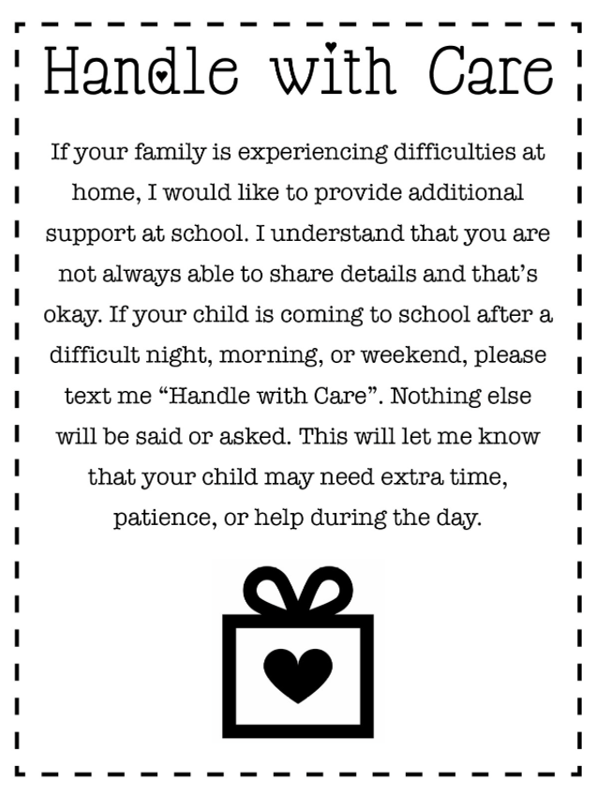

Any Questions?
Please feel free to contact me with any questions you may have. Thank you so much for your time reading our information guide. We appreciate your support helping us provide a safe and meaningful environment for all of our students. We are very excited about this school year and look forward to learning with your child!

Sincerely, Ms. Julie

Please return this portion below if you’d like to volunteer, thank you.

Parent Volunteers: Name: ________________________________

Yes, I am interested in helping with Advanced Practical Life activities such as:

Some field trip suggestions we have are:

